**How to Check the status of all service status in ansible-automation-platform 2.2 (using the ansible playbook)**

First we need to create one script file.



Give full permission to script file

[root@ansible ~]# chmod 777 system.sh

[root@ansible ~]# cat system.sh

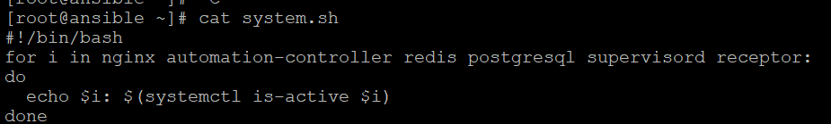

Now write one playbook to check all services are running

[root@ansible ansible]# cat service.yaml

---

- name: checking the status

hosts: localhost

remote_user: root

tasks:

- name: checking the status

shell: /root/system.sh

register: All_service_status

- name: showing report

debug:

var: All_service_status.stdout_lines

[root@ansible ansible]# cat service.yaml

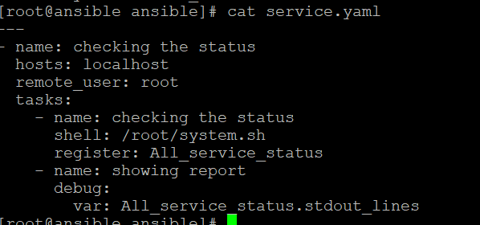

Now run the playbook

[root@ansible ansible]# ansible-playbook service.yaml –i inventory

